**Deployment Manual**

**Project Name: Library Management System**

**Team Members:**

**1. Mergu Anil**

**2. Nilesh Kumar**

**3. Nivi Infanta S A**

**4. Pachipulusu Sree Valli**

**5.Pawan Kumar Prajapati**

**1.GitHub Detail:**

**GitHub Link:** **https://github.com/cooolnilesh/LMS_Backend.git**

**https://github.com/cooolnilesh/L_M_S_Frontend.git**

**2.Passwords Used:**

**1. Oracle Database Credentials:**

* Username=NILESH
* Password= Nilesh123

**2. Application Default Login Credentials:**

* Username= Admin
* Password= Admin123
* Username= nilesh123
* Password= Nilesh123

**3.Port Numbers used inApplication:**

* **Spring Boot Application Tomcat Server Port Number=**8098
* **Angular Application Port Number =** 4200

**4.Angular Application Main Application Run Link:**

* **Link = http://localhost:4200**

**5.Steps To Add Project in local work Space from GitHub Using Git Bash:**

1. **Download git **
2. **Create Folder in workspace**
3. **Open git bash**
4. **Copy workspace Folder Path**
5. **Use cd command Then Paste the workspace path**

**$cd C:/Library_Management_System**

**6. Copy Link of GitHub Code then in Git Bash use git clone and paste thelink**

**$ git clone https://github.com/cooolnilesh/LMS_Backend.git**

**https://github.com/cooolnilesh/L_M_S_Frontend.git**

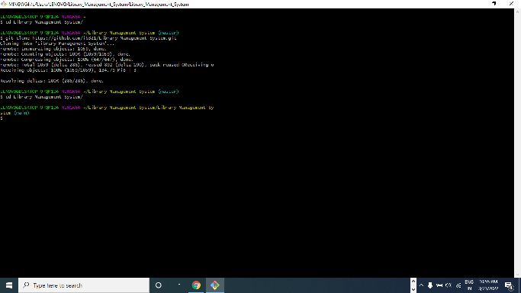

**7. Open Eclipse**

**8. Open Folder Path of cloned GitHub Java Project**

**There you need to uncompressed the Library_Management_System.rar file**

**Go to File Menu Choose “Open project from File System”**

**From there choose the project folder of uncompressed file.**

**9. Press Next and Finish Importing Library_Management_System project on eclipse**

**10. Right click on project Name**

**Go to Run as 🡪 1. Maven clean( then press F5 to refresh)**

**2. Maven build enter [ goals=clean install ]**

**11. Go to com.lib package then open Main Class** LibraryApplication.

**5.1. Maven Clean:**

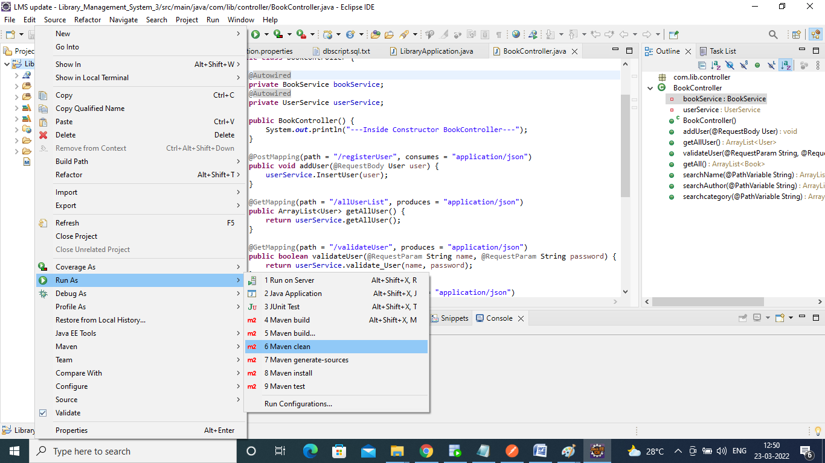

**5.1.1.Maven Clean Success:**

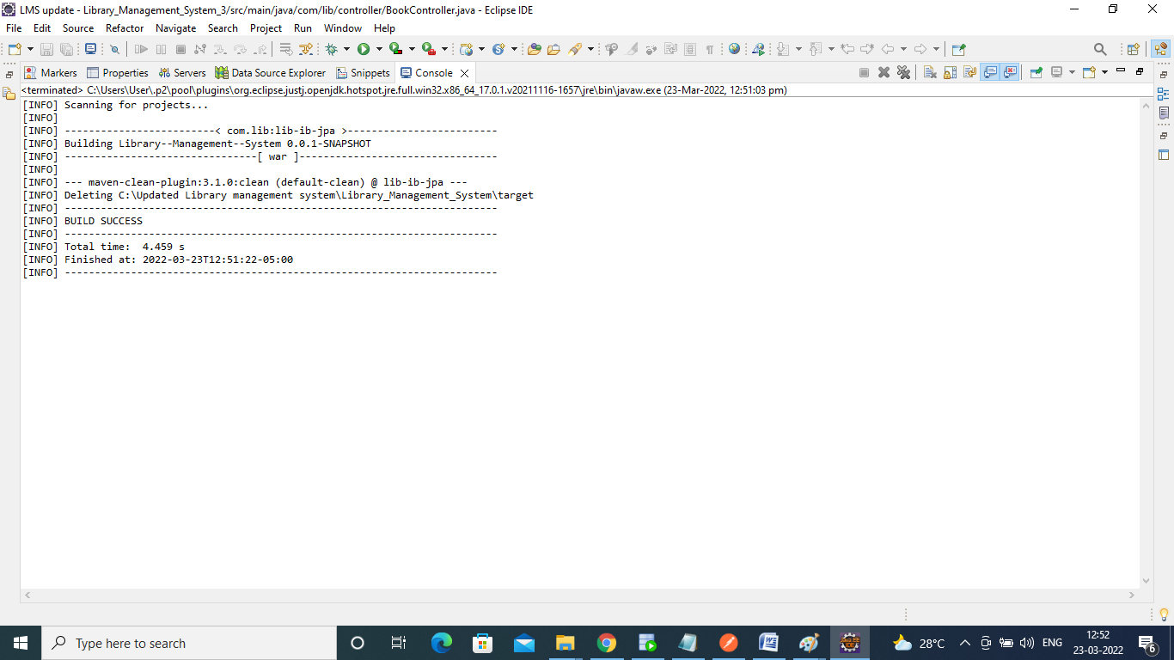

**5.2.Refresh:**

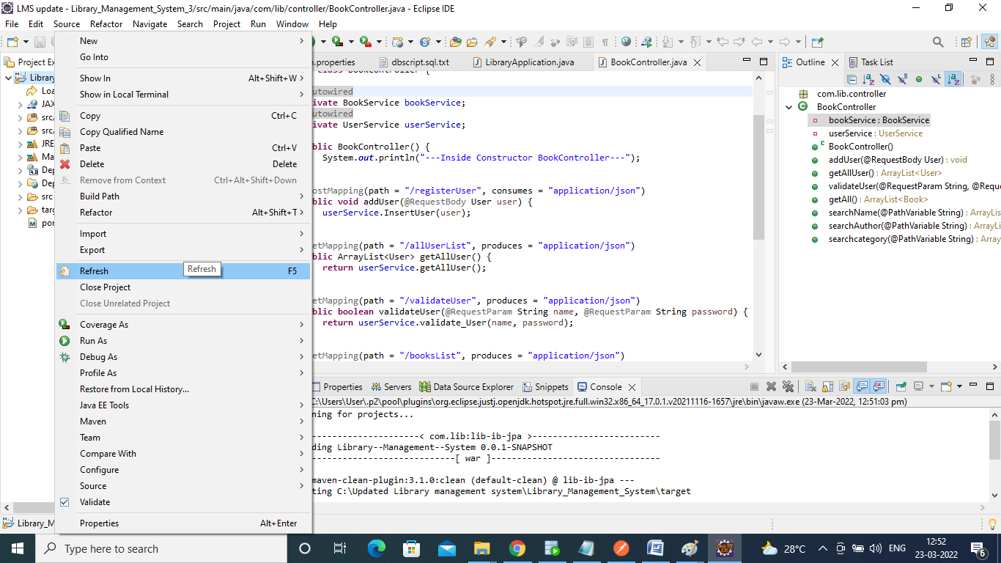

**5.3.Maven Build:**

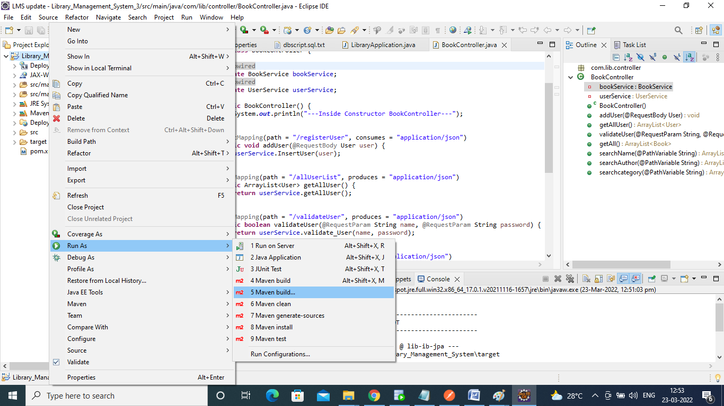

**5.3.1.Give Goals: “clean install”Apply then Run:**

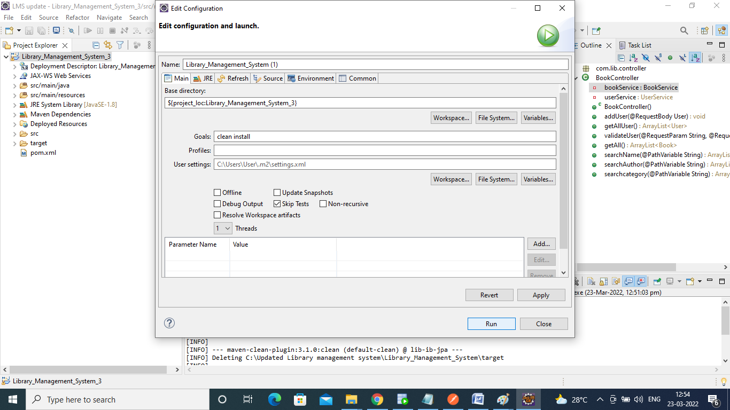

**5.3.2.Maven Build success:**

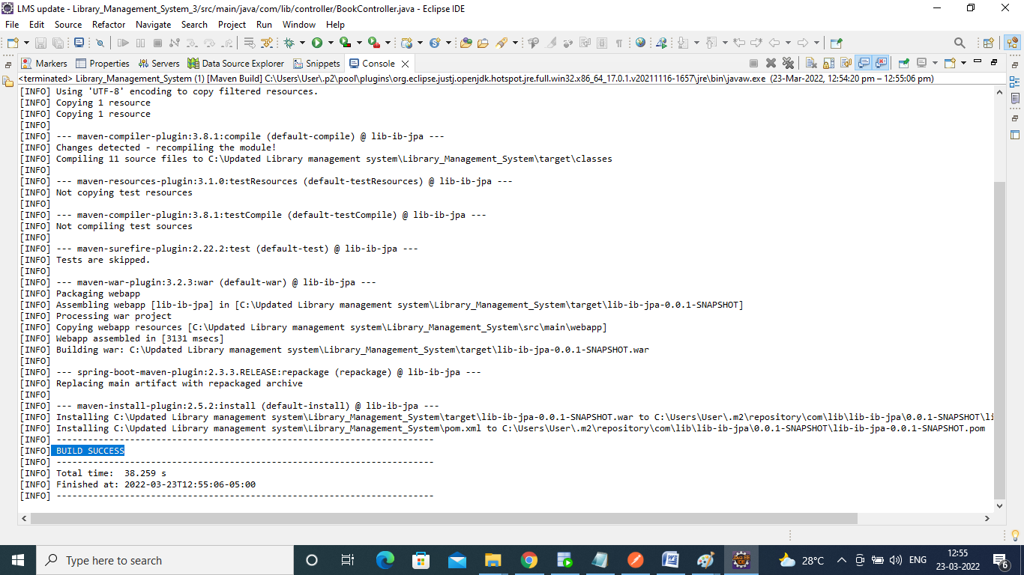

**12. Right click and Run As “Java Application”**

**6.Data Base:**

1. **We have to Download Oracle 11g and SQL developer**
2. **Then we can create tables Book, User_info**

**GitHub link for the Database script:**

* **GitHub Link for the Book Script:**

**https://github.com/cooolnilesh/LMS_Backend/blob/master/Library_Management_System/src/main/resources/Schema.sql.**

* **GitHub project link for User_info script:**

**https://github.com/cooolnilesh/LMS_Backend/blob/master/Library_Management_System/src/main/resources/Schema.sql.**

**6.1.Create tables:**

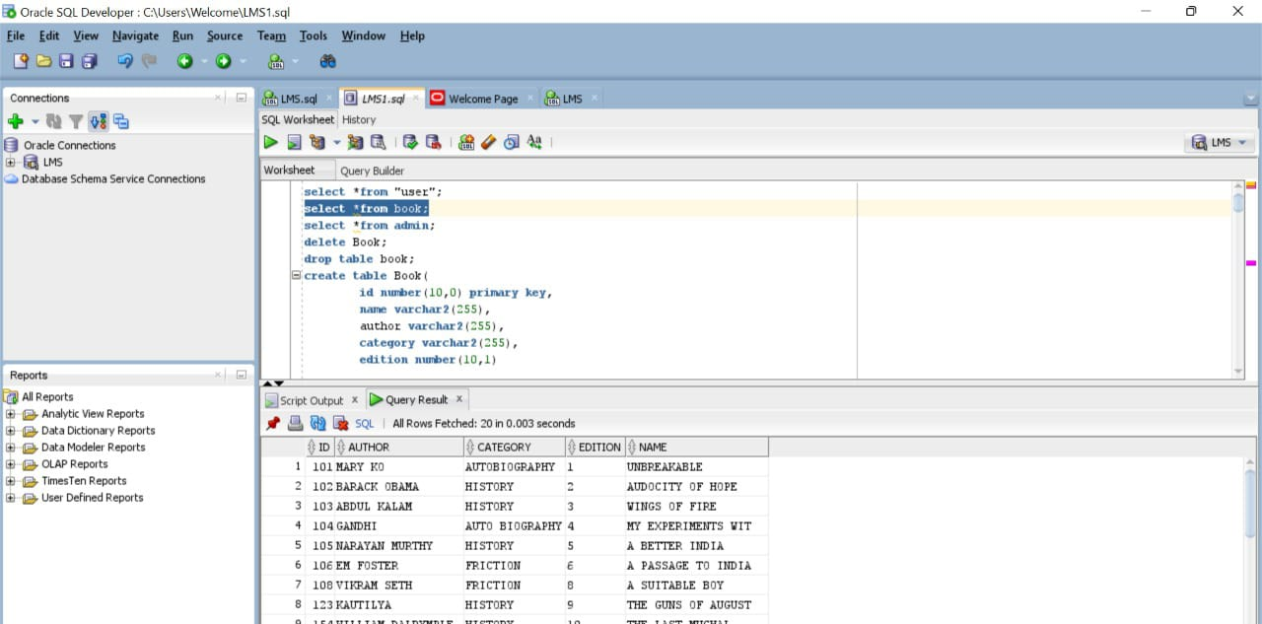

**7.Steps for UI:**

1. **First, we download**
2. **Download and install Node.js (including NPM) in windows system**

<https://nodejs.org/en/download/>

1. **Go to Command Prompt**
2. **Command to check the Node.js version installed in system: node -v**
3. **Install the Angular CLI: npm install -g @angular/cli**
4. **Command to check Angular version installed in your system:ng –version**
5. **Change directory to your application using: cd libraryApplication**
6. **Compile and Run the Angular App: ng serve**
7. **Open browser and access the Application using the below URL:** <http://localhost:4200/>

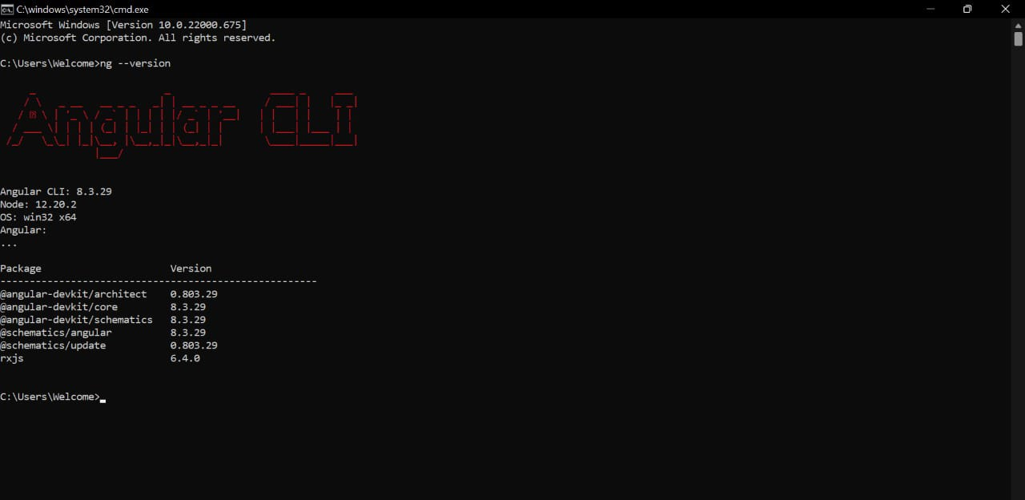

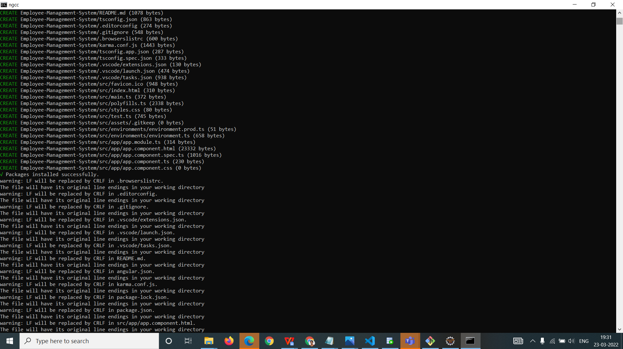

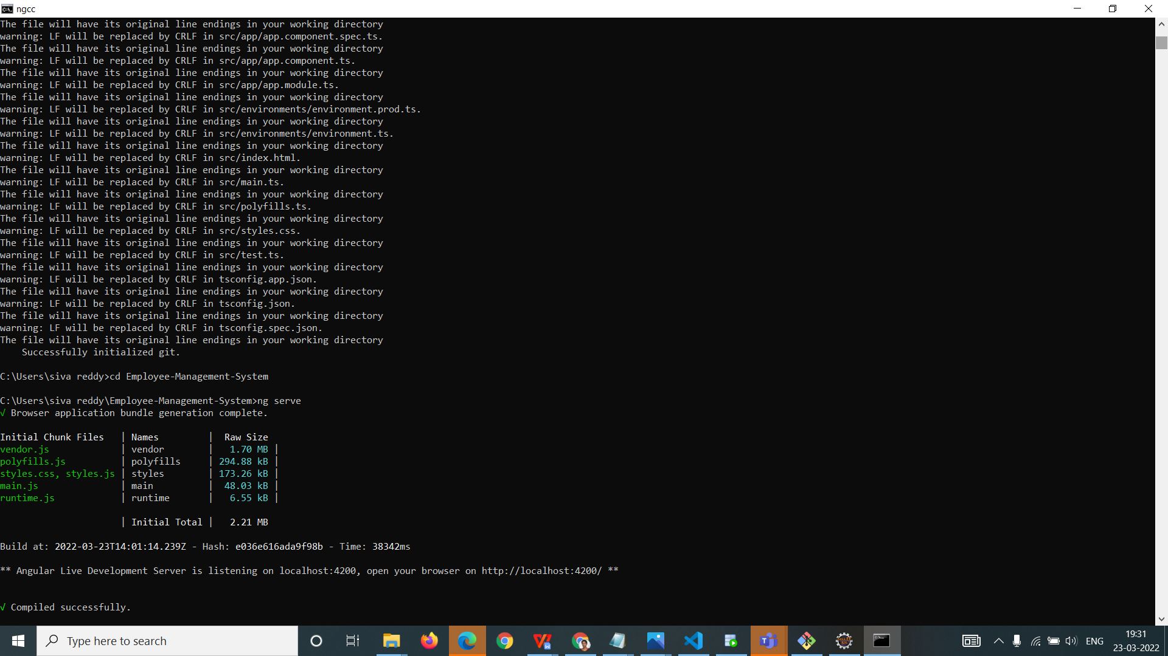

**8.Project Testing / Access:**

1. **Open URL :**<http://localhost:4200/> **from browser**
2. **To login into the application use Default Login User id and Default Login Password.**
3. **Once you successfully log into the application, you can use the below application functionalities:**
4. **Search by Book Name**
5. **Search by Author Name**
6. **Search by Category**